Choose a Location

Suggested Equipment  Air Sample Pump  Tripod  Sample Cassette (4in)  Paper Filter (4in)  Quart Sealable Bag  Tweezers  Security Seal  Sample Control & Chain of Custody form  Generator (if required)  Extension Cord (if required)  Gloves | 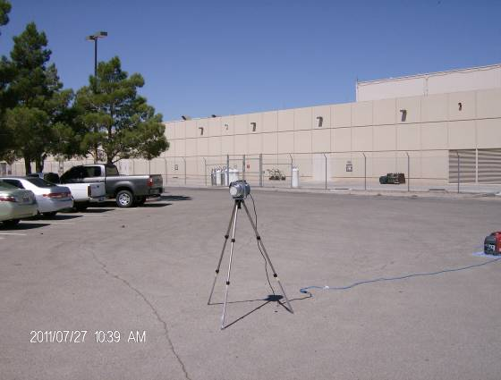 | 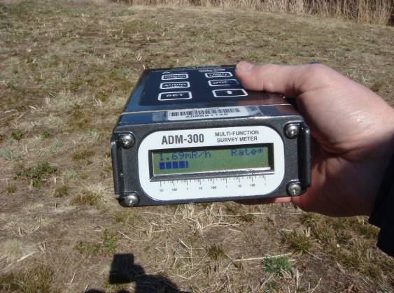
Gather all the required equipment before you depart for the field. This is a list of suggested equipment. Add or remove equipment as needed. | Locate the pump in an open area away from buildings, trees or other overhead obstructions. Rule of thumb is to locate the pump at least two times the height away from the closest obstruction. | Perform an exposure rate survey (waist high) and a contamination survey (ground). Record the measurements.
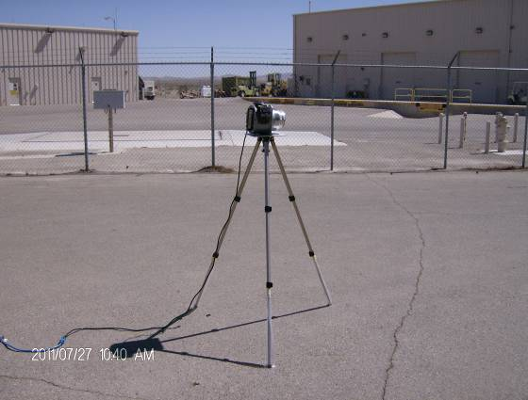 | 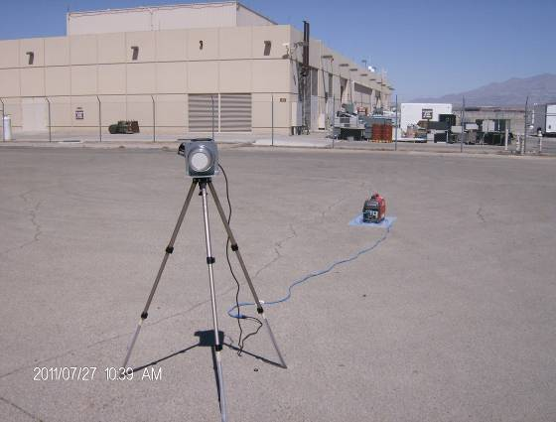
Position sample head approximately 1.5 meters off the ground (approximate breathing zone height). Point the Sample Head in the direction of the release. | If using a generator ensure the exhaust is downwind from the sample head. | Take a picture of the Air Sample Pump and surrounding Area. Submit with the other sample collection information.

Assemble the Sample Head

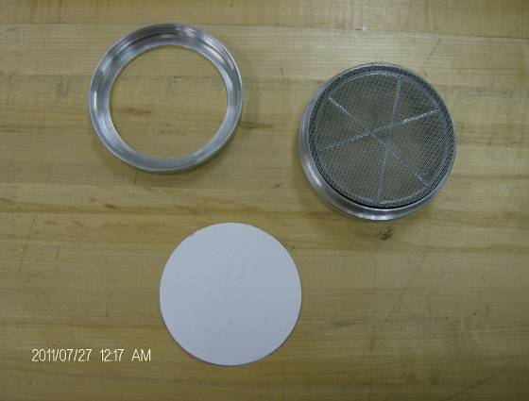 | 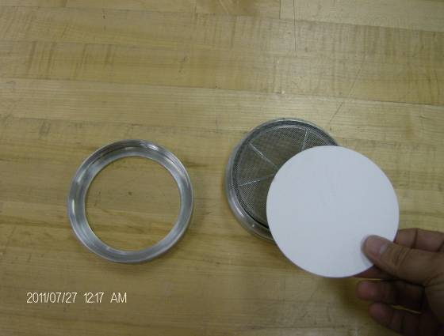 | 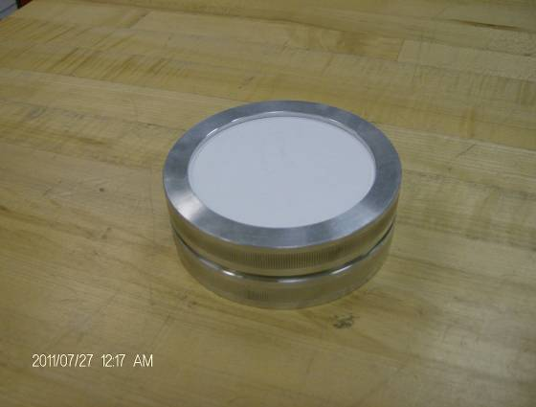
Air Sample Cassette, paper filter. | Install the paper filter fuzzy side out.  If the front and back of filter cannot be determined, than place an ink spot on the front of the filter near the edge. Record this in the comments on the Sample Control Form. | Assemble the cassette.
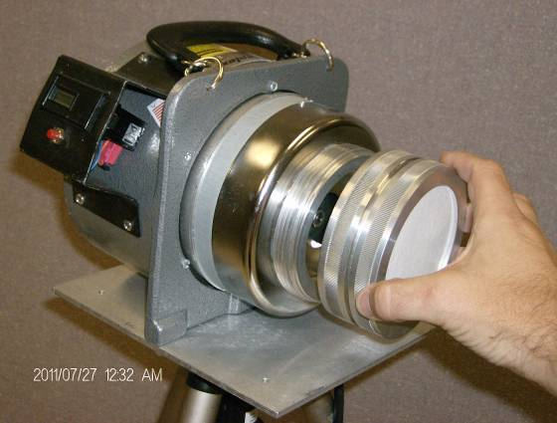 | 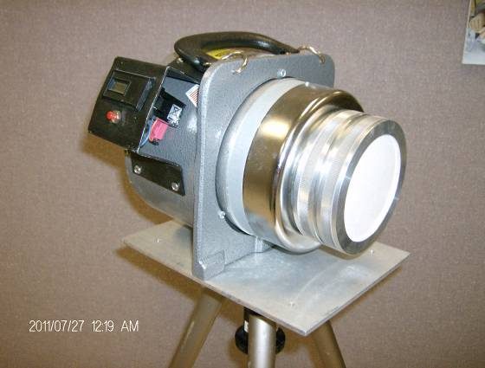 | 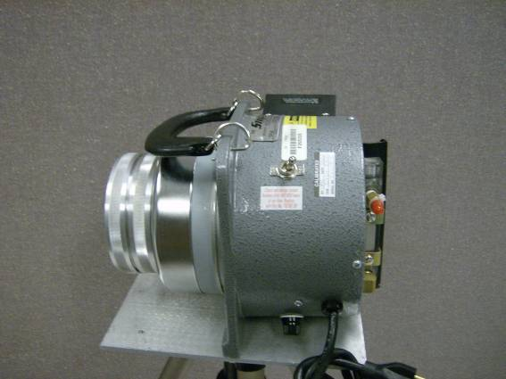
Attach the Sample Cassette to the Pump.  Zero out the run time meter. | Air sample Cassette installed. | Start the air sample.

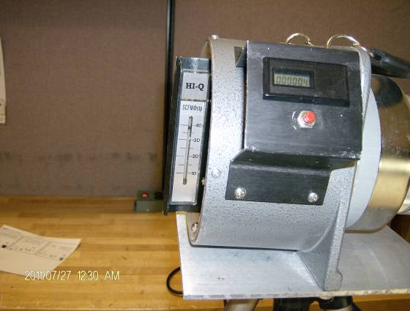 | 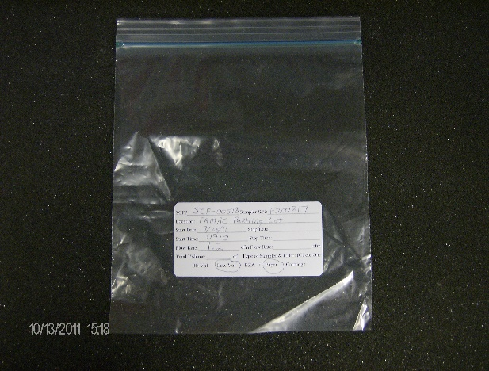 | 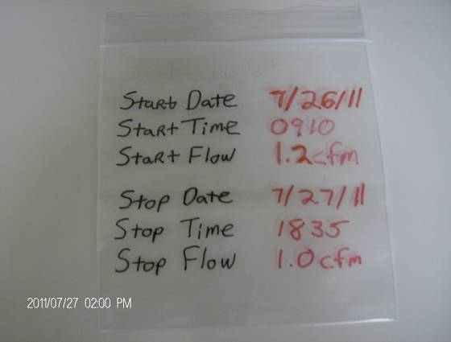
Check the Flow Rate. | Record start date/time and flow rate on the sample bag. If required, record the start of the generator runtime. Put a barcode on the bag. | Before you STOP the pump, record stop date/time and flow rate on the sample bag.
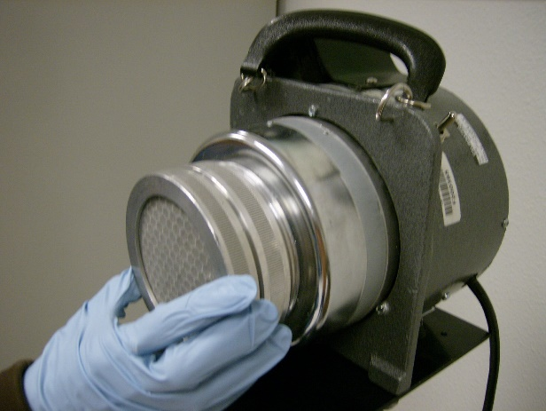 | 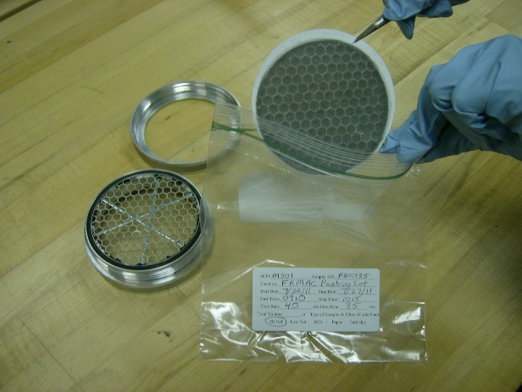 | 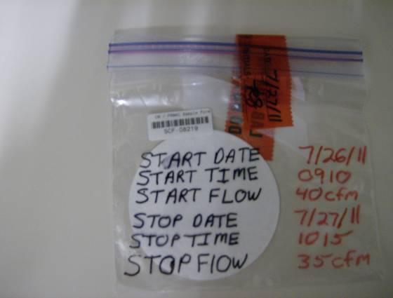
Remove the Sample Cassette. | In a secure location, using tweezers, place the filter paper in a sample bag. Place a Security Seal on the bag. | Complete a Sample Control and Chain of Custody Form for each sample and input into the tablet. In the comments, reference the associated SCF number.  If background permits, survey the sample bag and record results on the SCF.

