Suggested Equipment  Soil Sample Jig (10 x 10 x 2 cm)  Claw Hammer  Gallon Sealable Bag  Bags, 15 x 24  Security Seal  Sample Control & Chain of Custody form  Gloves | 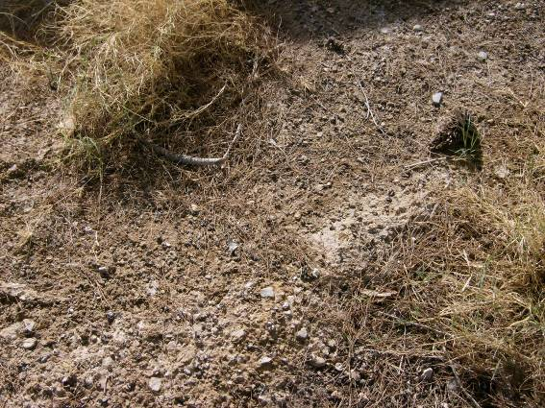 | 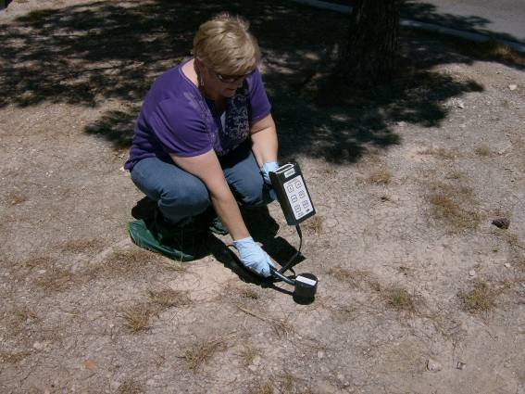
Gather all the required equipment before you depart for the field. Place into 15 x 24 bag to carry to sample location. This is a list of suggested equipment. Add or remove equipment as needed.  Collect and bag Soil and Vegetation as one. | Choose a location to collect the Ground Deposition sample in an open area, away from buildings, trees, or other overhead obstructions. Choose a location with as little vegetation as possible. Less than 6 inches high of vegetation is recommended. | Perform an exposure rate survey (waist high) and contamination survey (ground). Record the measurements.  Take a picture of the sample location and surrounding area. Submit with the other sample collection information.
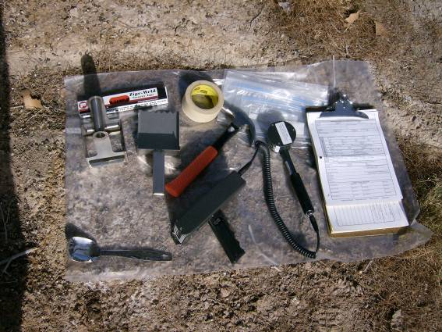 | 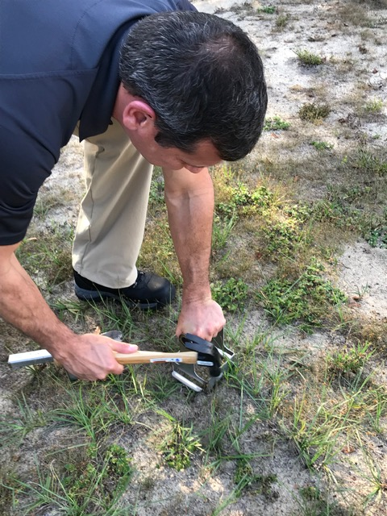 | 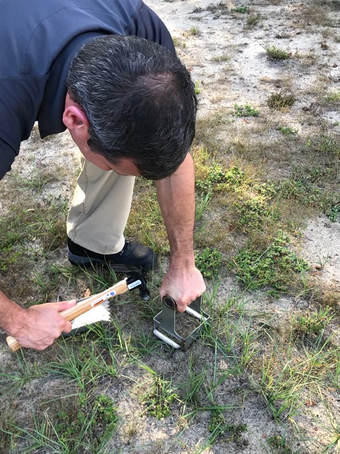
At the sample location, arrange all needed supplies on a clean surface | Place jig at the sample location, with as little vegetation as possible. No more than 6 inches of grass or material. | Push the jig to 2 cm depth. Tap with the hammer if needed.

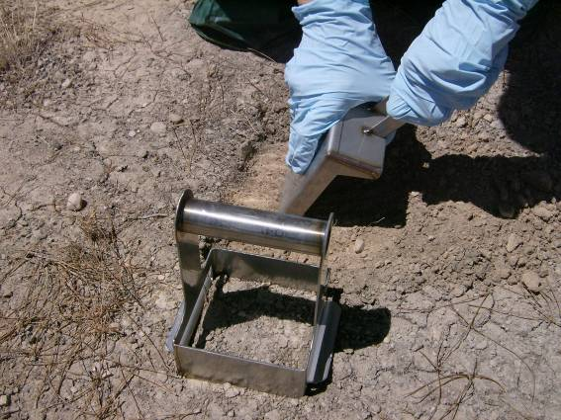 | 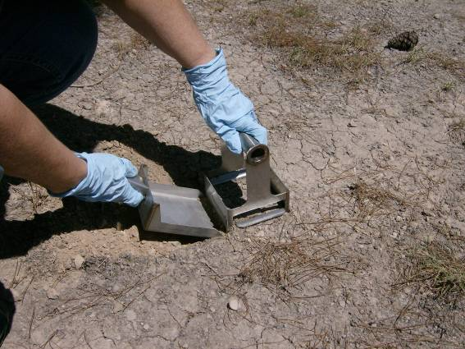 | 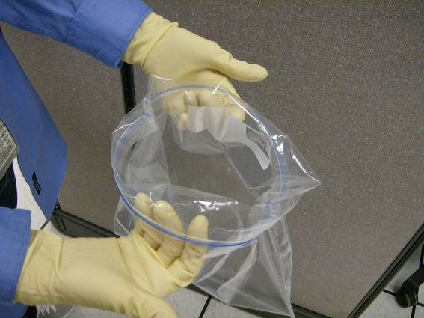
Dig a trench with the trowel. Use claw hammer if needed to loosen the soil. | Slide the trowel under the jig. Use the hammer if necessary to push the trowel under the jig. | Clean Person: Roll the bag until a lip has been created. Hold bag under lip ensuring that the bag remains open for the Sampler to place the sample (soil and vegetation) into the bag, without touching the outside of the bag.
 |  | 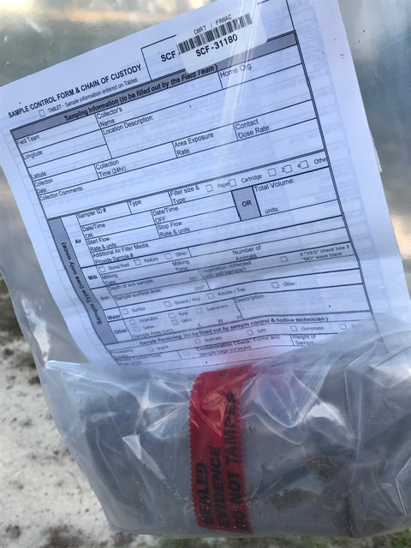
Pick up jig and trowel with the sample (soil and vegetation). Place content into 1 gallon sealable bag. | Roll the bag around the sample.  Keep the opening away from breathing area. | Place a SCF barcode and Security Seal on the bag. Complete the Sample Control and Chain of Custody Form and input into the tablet.  If background permits, survey the sample bag and record results on the SCF.

