Suggested Equipment  Pruning Shears  Gallon Sealable Bag  Bags, 15 x 24  Tape measure  Grass Clippers  Knife  Security Seal  Sample Control & Chain of Custody form  Gloves | 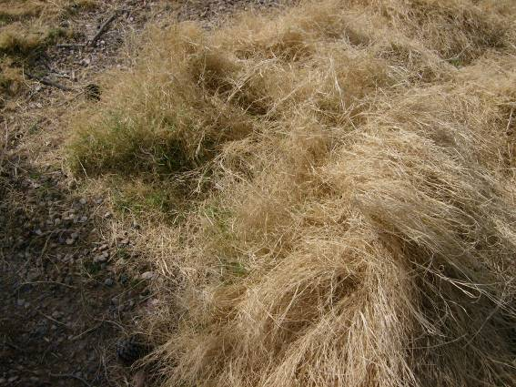 |  | 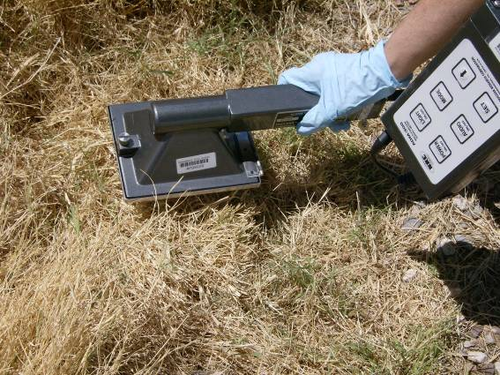
Gather all the required equipment before you depart for the field. Place into 15 x 24 bag to carry to sample location. This is a list of suggested equipment. Add or remove equipment as needed. | Choose a location to collect the sample.  Locate the sample out in the open, away from buildings, trees or other overhead obstructions.  Take a picture of the sample location and surrounding area. Submit it with the other sample collection information. |  | Perform an exposure rate survey (waist high) and a contamination survey (ground). Record the measurements.
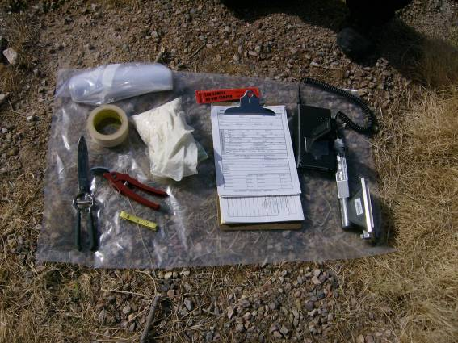 | 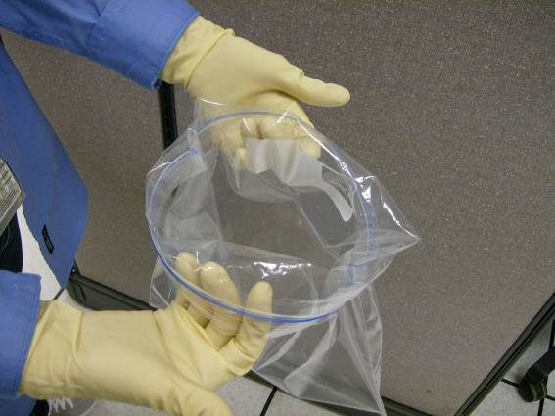 |  | 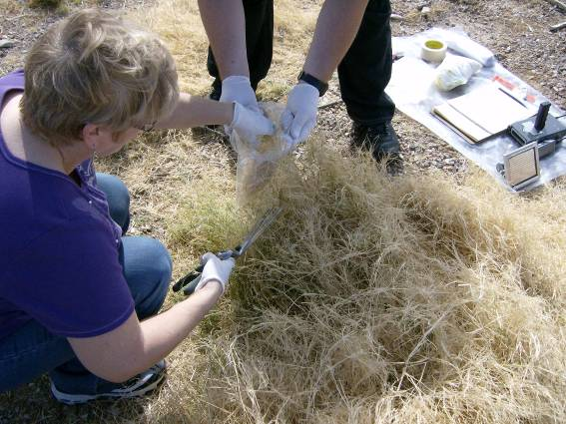
At the sample location, arrange all needed supplies on a clean surface. | Clean Person: Roll the bag until a lip has been created. Hold bag under lip ensuring that the bag remains open for the (Sampler) to place the sample into the bag, without touching the outside of the bag. |  | Only collect the edible portions of the plant. Clip pieces 6 inches or less (to fit in the bag).  Stop before the bag is bulging and will not seal.
 |  | 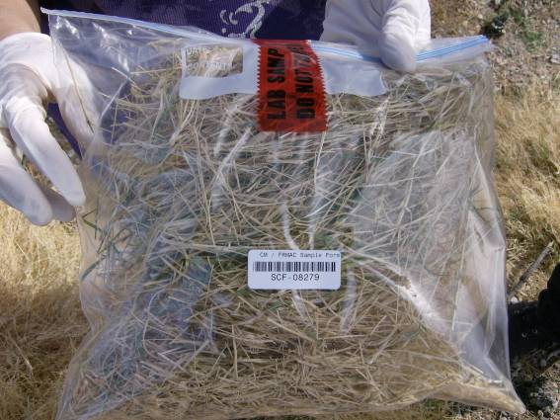
Measure the length, width and depth of the sample collected. Record this information. |  | Place a SCF barcode & Security Seal on the bag. Complete the Sample Control and Chain of Custody Form and input into the tablet.  If background permits, survey the sample bag and record results on the SCF.

