Choose a Location

Suggested Equipment  Sample Container (1 Gallon / 4 Liter Cubetainer)  Funnel  Bucket  Rope  Bags, 15 x 24  Security Seal  Sample Control & Chain of Custody form  Generator (if required)  Extension Cord (if required)  Gloves  Distilled or deionized water | 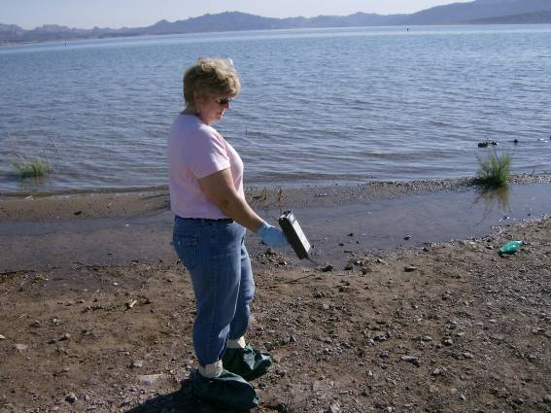 |  | 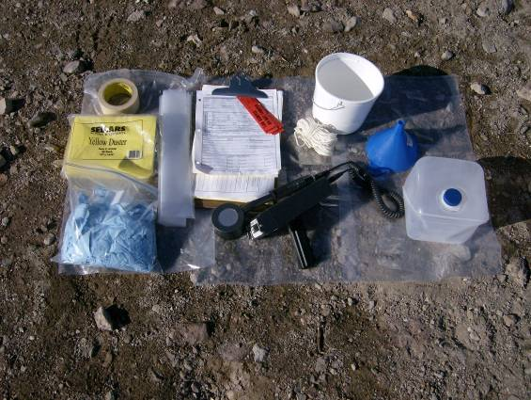
Gather all the required equipment before you depart for the field. This is a list of suggested equipment. Add or remove equipment as needed. | Choose a sampling location. Perform an exposure rate survey (waist high) and a contamination survey (ground). Record the measurements. Take a picture of the sample location and surrounding area. Submit with the other sample collection information. |  | At the sample location, arrange all needed supplies on a clean surface.
Choose a location to collect the sample. Ensure enough water is available to fill a one-liter sample container. | 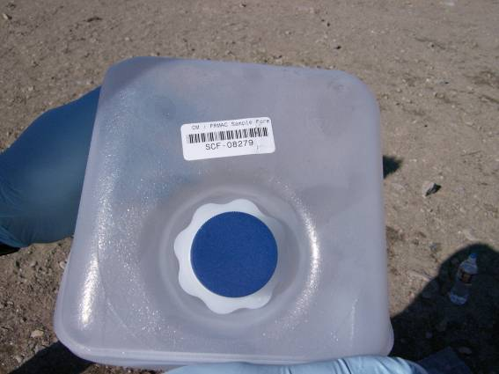
Choose an area that is open, not sheltered by trees or high brush. Little or no current. | Place a SCF barcode on the sample container. |  | Rinse out the sample container and cap with deionized or distilled water.
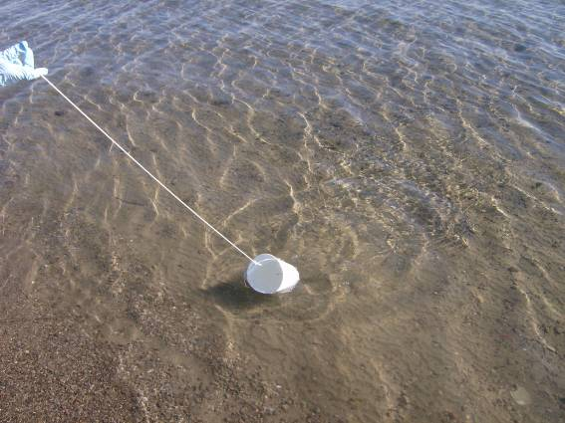 |  | 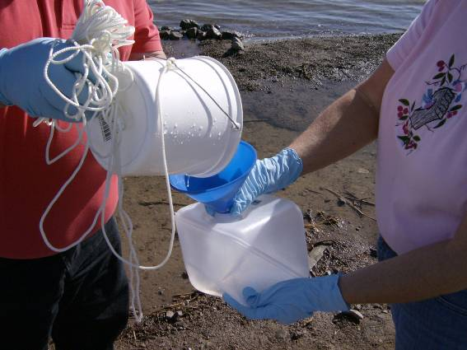 |  | 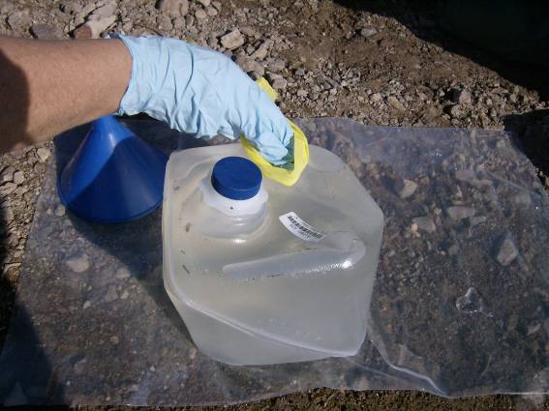
If needed attach the rope to the bucket.  Collect the surface water. |  | Using the funnel, fill the 1 gallon (4 liter) sample container. Stop 1 inch from the top. |  | If needed, rinse the outside of the container with deionized or distilled water. Dry the outside of the sample container.
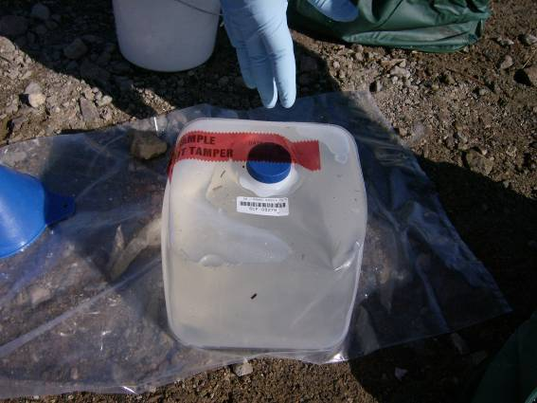 |  | 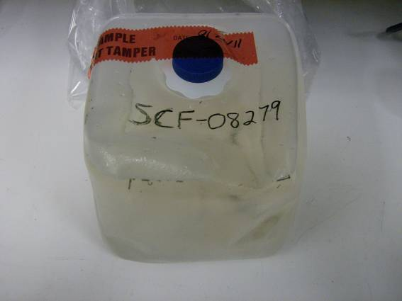 |  | 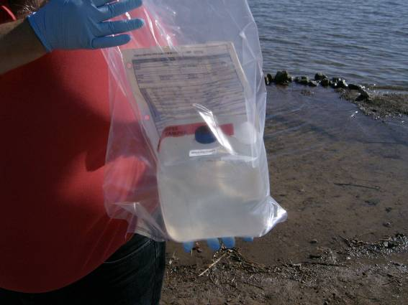
To prevent leaks, wrap tape around the lid and container (not shown in the picture). Place a Security Seal over the opening. |  | If needed, use an indelible marker to write the SCF Number on the sample container.  Place into a clean plastic bag. |  | Complete the Sample Control and Chain of Custody Form and input into the tablet.  If background permits, survey the sample bag and record results on the SCF.

