Suggested Equipment  Sample Container (1 Gallon / 4 Liter Cubetainer)  Funnel  Bucket  Rope  Bags, 15 x 24  Security Seal  Sample Control & Chain of Custody form  Gloves  Distilled or deionized water | 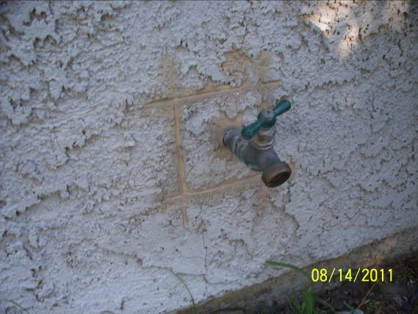 | 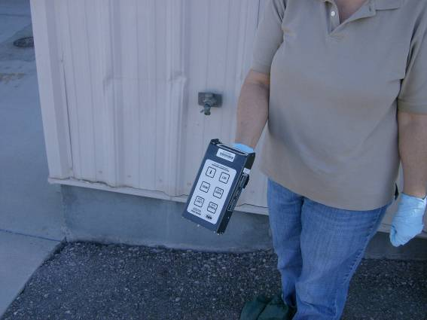
Gather all the required equipment before you depart for the field. This is a list of suggested equipment. Add or remove equipment as needed. | Choose a location to collect a tap or well sample.  Take a picture of the sample location and surrounding area. Submit with the other sample collection information. | Perform an exposure rate survey (waist high) and contamination survey (ground). Record the measurements.
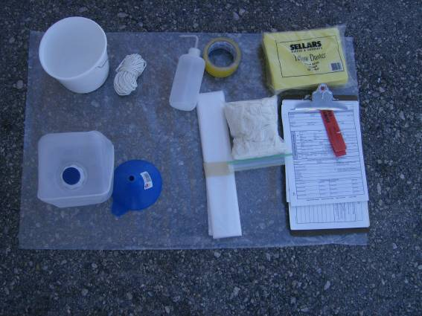 | 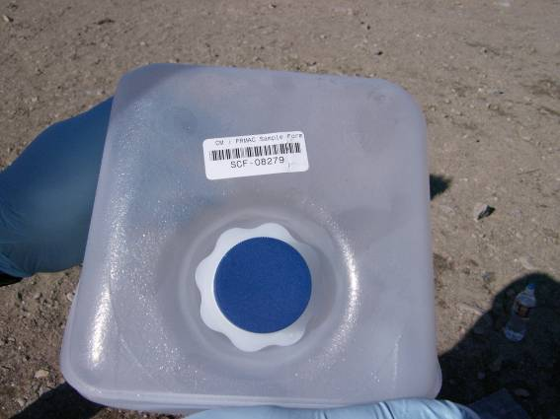 | 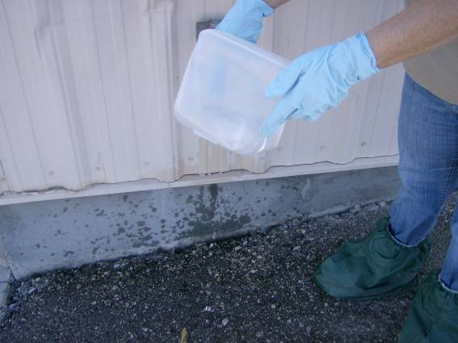
At the sample location, arrange all needed supplies on a clean surface | Place a SCF barcode on the sample container. | Rinse out the sample container and cap with deionized or distilled water.  Purge the tap to get a sample from the well supply and not the lines.

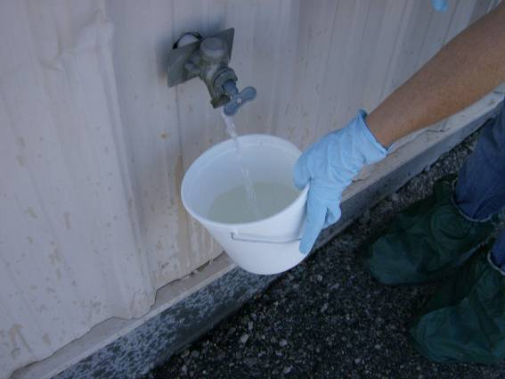 | 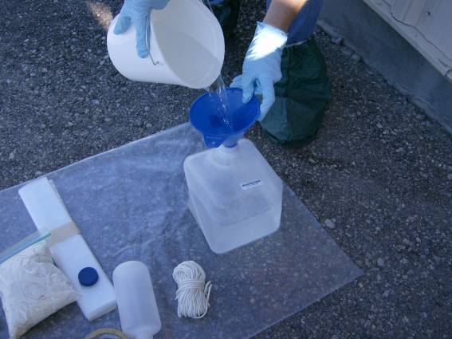 | 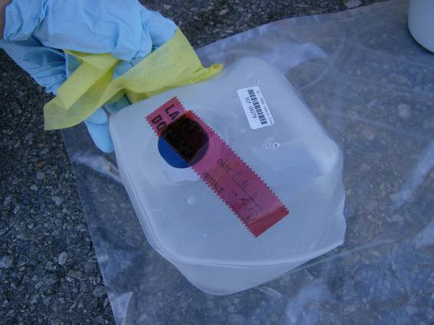
Fill the bucket. | Using the funnel fill the 1 gallon (4 liter) sample container. Stop 1 inch from the top. | If needed, rinse the outside of the container with deionized or distilled water. Dry the outside of the sample container.
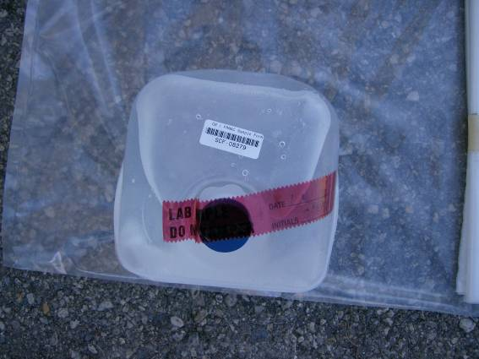 | 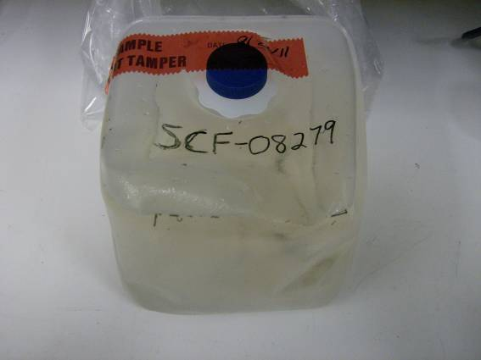 | 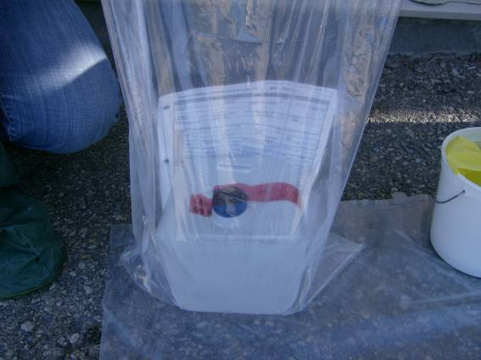
To prevent leaks, wrap tape around the lid and container (not shown in the picture). Place a Security Seal over the opening. | If needed, use an indelible marker to write the SCF number on the sample container.  Place into a clean plastic bag. | Complete the Sample Control and Chain of Custody Form and input into the tablet.  If background permits, survey the sample bag and record results on the SCF.

