Suggested Equipment  Generator  Gasoline  External Gas Tank (if required)  Extension Cord (if required)  Gloves  Screwdriver  Drip Pan (if required)  GFI Adapter  Fire Extinguisher (if required) | 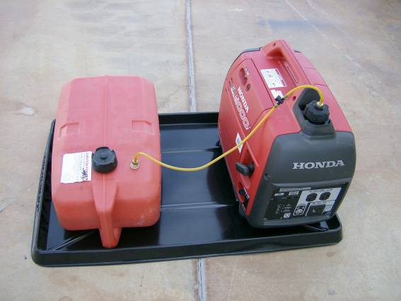 | 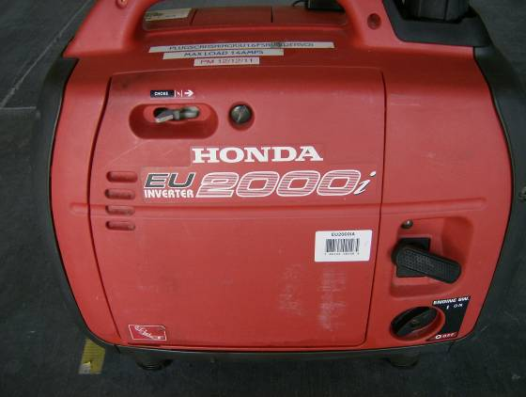
Gather all the required equipment before you depart for the field. This is a list of suggested equipment. Add or remove equipment as needed. | If required, place generator in a Drip Pan. If using an external tank make sure they are on the same level. Fill both tanks with gasoline. Use a funnel if needed. If using the external tank ensure the generator tank is completely full. Open the Breather valve on the gas cap. The valve on the external tank is Open when it is parallel to the hose. | Turn the engine switch to ON  Move the Choke to Full  Pull the handle until the engine starts.  Wait until engine warms up, move half. After 1 minute or so move the choke to Run.
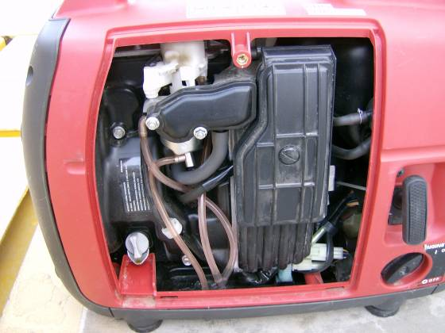 |  | 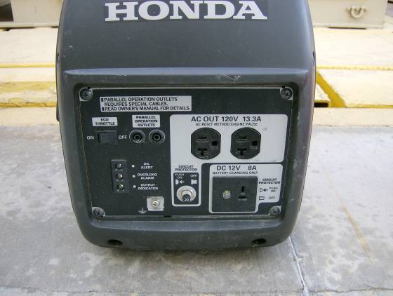
If the generator has not been used recently and will not start:  Open the engine cover. Loosen the screw to the fuel drain. Pull the handle until gas flows. Close the drain screw and engine cover. | Pull the handle until the engine starts.  Wait until engine warms up, move half. After 1 minute or so move the choke to Run. | Eco Throttle should be ON to conserve fuel. Do not overload the circuits. If Overload Alarms is lit, turn Off generator and check circuits. Than restart generator. If Oil Alert light comes on, check Oil level.

