Introduction
The purpose of taking high-purity germanium (HPGe) in situ spectra in the early stages of an event is to measure the isotopic ratios and concentrations. The ratios provide information on what materials were released, and how they settled to the ground. The concentrations provide absolute measurements of how much material settled. Both of these items are important when estimating the doses people will receive.
When in situ measurements are repeatedly performed at the same location, information on how the deposited radioactivity is changing can be assessed. In the early stages of an event, the radioactivity may be increasing, indicating that material is settling to the ground. Later measurements are expected to provide information on how the deposited activity is weathering. Weathering can mean migration of the material into the soil through precipitation or removal/redistribution by such things as wind, rain, or decontamination efforts.

Equipment Required to Perform Measurement
- ORTEC Detective
  - Charging station (Bring to the field)
  - AC and DC power cords
  - External battery (2590 w/cord)
  - SD Card
- Tripod kit
  - Contamination control sleeves for the legs
- CM Tablet
  - USB to SD card reader
  - External battery supply
  - Power cord
- Multi Path Communication Device (MPCD)
  - Entire inventoried kit
- Handheld Radiation Detection equipment i.e. Frisker, dose rate meter
- Known Cs-137 source (Do not bring into the field)

Equipment Preparation
- Inventory all equipment
  - ORTEC Detective
  - Power adapter and cables
  - Battery pack and cables
  - SD card
  - Tripod with bags on legs for contamination control
  - FRMAC tablet
  - Laptop computer (optional)
  - GPS (optional)
  - Camera (optional)
- Confirm/Set date and time to local time on Detective
- Check/Update the energy calibration on Detective
- Check preset time (if available)
- Check/Update spectrum storage location to SD card
- Check spectrum file format is set to both Ortec and ANSI
- Set/Update default description (FIS# and team)
- Perform an automatic energy calibration

System Setup
- Connect the Detective into the charging station, then using either the AC or DC power cord, plug the station into a power source.
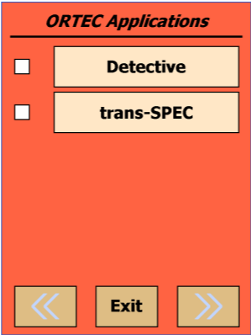
- Turn on the PDA and check the systems Date and Time.
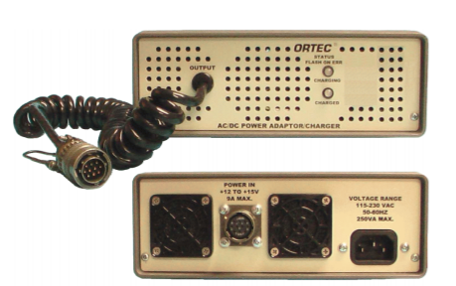
- Choose the Detective program if at the Windows start screen.

Detective Selection Screen
Charging Station

- Select Advanced
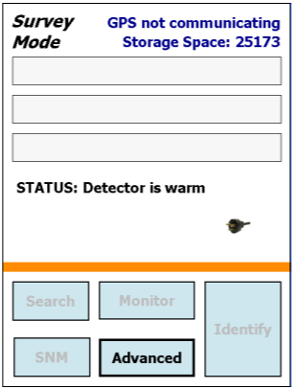
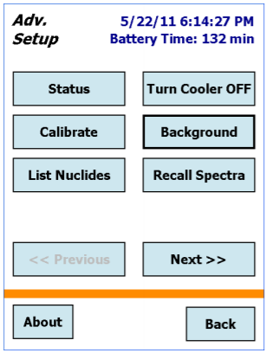
- Select Turn Cooler ON

Cooler Controls
Advanced Menu

- The Detective must be plugged into the charging station to start the cooler and get it to the proper operating temperature
Note: The detector may need 24 hours to reach the operating temperature.
- Set Spectrum Storage location by clicking on the Advanced menu.
- Then More (Next) until you can Choose Spectra.
- Under Data Location: Choose Storage Card/Data then under File Save Format: Choose Both Ortec and ANSI
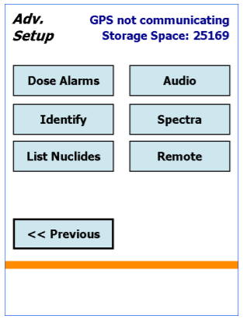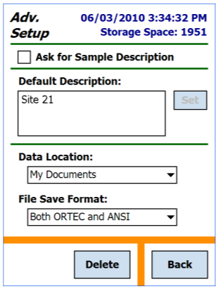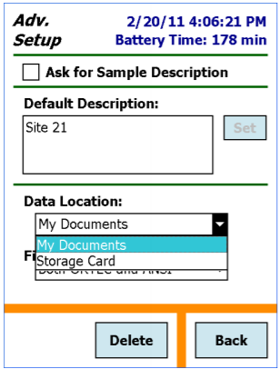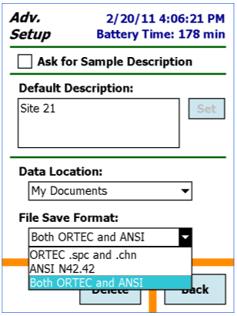
Advanced Menu / Next Advanced Menu (Spectra) Data Location Selections File Formats

Note: Ensure the Detective has an SD Card inserted. There is a Lock switch on the left side of the SD card. Make sure the Lock switch is in the unlock position.
- Set Sample Time by clicking on Advanced then Search and moving the slider to (1s).
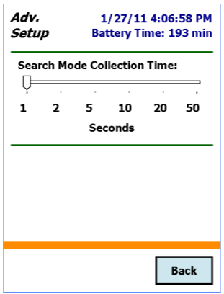
Sample Time Setting
- Set Count Time by Selecting the Advanced button, then More(Next).
Select the Identify button this will bring up the Real Time Preset box.
  - Set to 600 seconds for 10 min count (or whatever count time you were instructed). Be sure to press SET if you change the time.
  - Then press Back, Previous, and Back to get back to the main screen that has the Identify button.
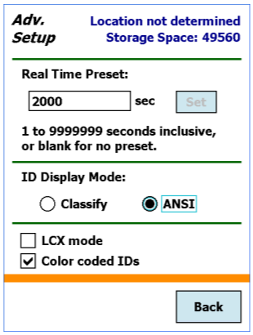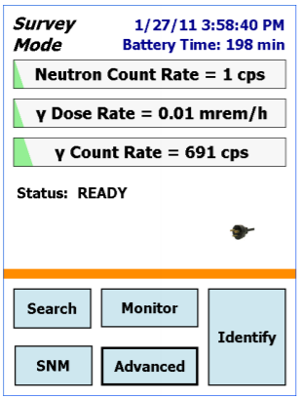
Advanced Menu / Next Where to set count time presets Main User Screen

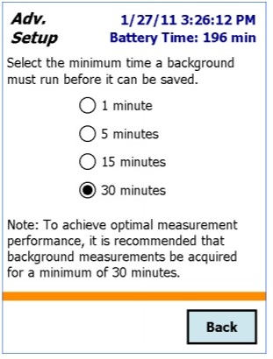
Automatic Energy Calibration of the ORTEC Detective
Resources: Detective and a 1µCi to10µCi ¹³⁷Cs source
- Ensure the in situ system is cooled down and ready to operate.
- If the Detective is connected to a computer via USB cable,
disconnect it.
- Before calibrating the Detective, set the Background count
time. Select Advanced, then Next to get to the Bkg Settings.
Make sure it is set for 5 Minutes. Then go back to the previous screen.
- Select the Calibrate button. Place the Cs source in front of the Background Time Setting
detector then Select the Start Calibration Now button on the Detective.
Follow the instructions on the PDA screen.
  - If improved calibration is found, choose Use Improved Calibration.
- At this point you will have to take a new Background.
  - Remove the Cs source from the area (it will interfere with background reading if nearby).
  - Select the Background button.
Note: This Background will be saved on the Detective’s internal memory, not the SD card.

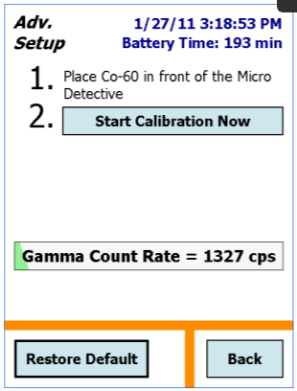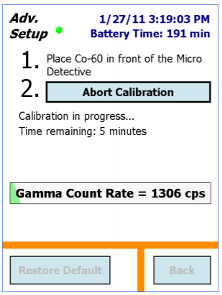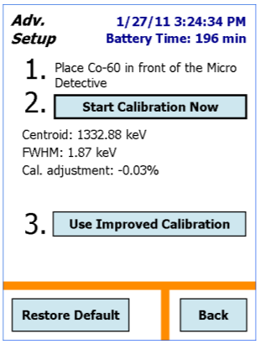
Calibration Start Screen Calibration in progress screen Calibration Completion Screen
Setup for Background and Known Source Measurements

Before departing, unless told otherwise, take a 10 minute count with a Known Source (Cs-137) and a 10 minute Background outside the Technical Operations Center (TOC). Save this on the SD Card and then using the Card Reader and the MPCD Tablet send this Data to RAMS before leaving for the field.

Prior to field team departure
- Ensure the in situ system is cooled down and ready to operate.
- Set the required measuring time as indicated in the field team instructions (Reference Page 5 of this document).
- Assemble Tripod and tape the Tripod feet up to prevent contamination.
- Collect a background in situ measurement preferably in a low background area that will be representative of the sampling area. Be sure that no check sources are nearby. Reference pages 8-11 for selecting a site, in situ setup, and measurement collection.
  - Record the file name. Once the file can be renamed, rename it with a unique name as well as an indicator that the spectra is a background (example: FIS-9_Alpha_12-25-2020_BKG).
- Collect a spectra of a known radioisotope. This can be done at the same location as the background (as long as the addition of a radioactive source will not interfere with backgrounds being performed by other teams). Reference pages 8-11 for selecting a site, in situ setup, and measurement collection.
  - Record the file name. Once the file can be renamed, rename it with a unique name as well as an indicator that the spectra is a known source (example: FIS-9_Alpha_12-25-2020_KNOWN_Cs).
- Submit in situ measurements via the tablet (Reference page 12 of this document).

Site Selection (Best Practices)
- Upon arrival at the pre-determined location, choose an area that is flat and without large obstructions (walls, berms, ditches, or cliffs) to a radius of 50 ft, and do not have heavy foliage overhead or other overhangs. The area should have minimal or no ground disturbance (i.e. that the land has not been plowed, or any other activity, that has unnaturally mixed the soil since the radionuclide deposition).
- Use a handheld exposure rate meter to perform rough surveys of about 20x20 feet to see that the rate is constant (within measurement errors). Select an area that ensures a dead time maintained at or below 60% if possible. General guidance is an area that is < 3 mR/hr.
In situ measurement site guidance:  - Sampling should be conducted only in undisturbed environments.  - Area exposure rate should be less than 3 mR/hr or result in dead time that is less than 60%.  - Ensure a photo is taken of the area.  - This page shows examples of suitable locations for in situ measurements. | 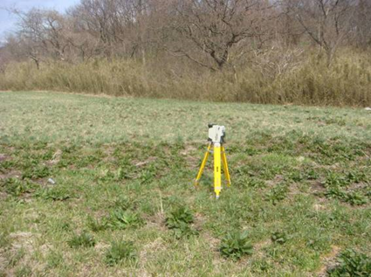 | 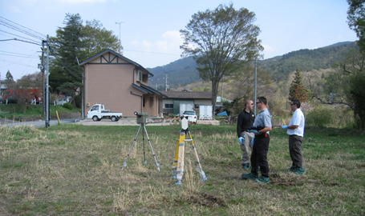
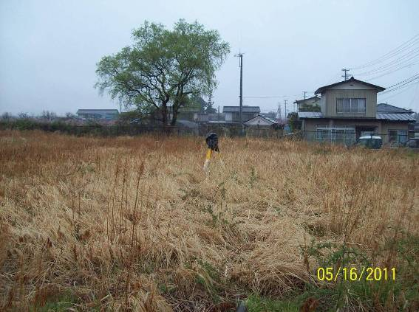 | 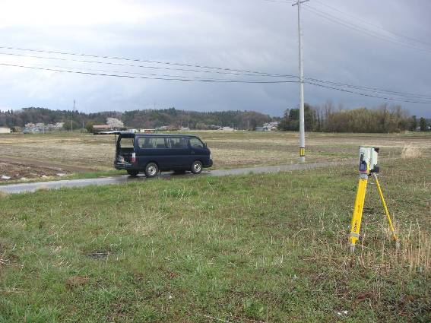 | 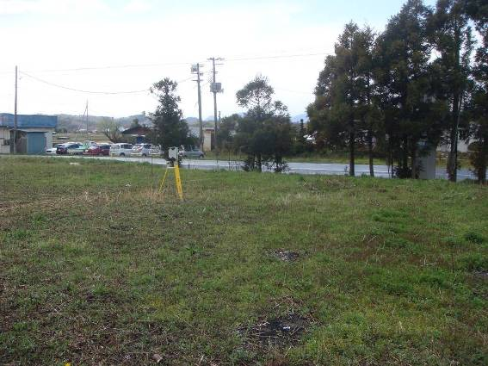

Site Selection (Undesirable)
If you are unable to find an ideal location close to the location in the field team instructions, collect the measurements and record all the issues. Ensure a photo is taken of the area.  This page shows examples of less than desirable locations for in situ measurements. | 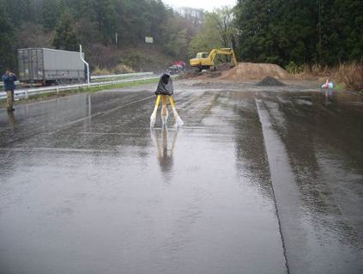 | 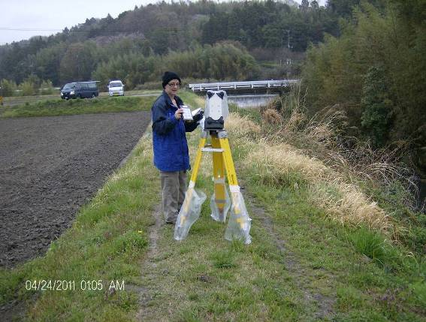
 | This would be a good location if the parking lot was undisturbed and the rain had not washed out the deposition. | Drop off or discontinuity present. Also unknown when the soil disturbance occurred.
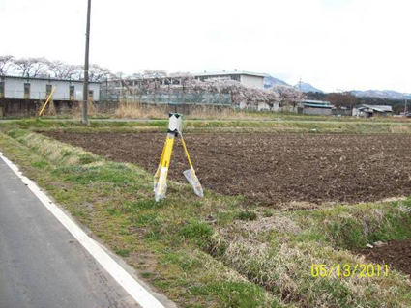 | 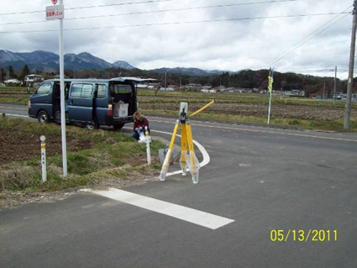 | 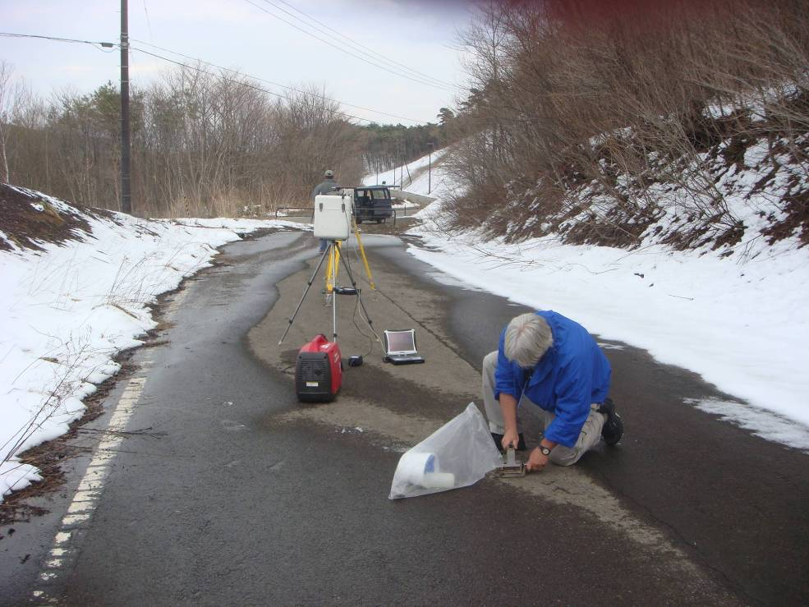  Berm
Avoid tilled fields, pavement, and vegetation-pavement transition.  Culvert or discontinuity present. Unknown when the soil disturbance occurred. | Pole and culvert too close. Unknown if the road is open to traffic. A possible mix of undisturbed and disturbed deposition present. | If the road is open to traffic, disturbed deposition present. In between two berms on each side of the road.
HPGe In Situ System Setup
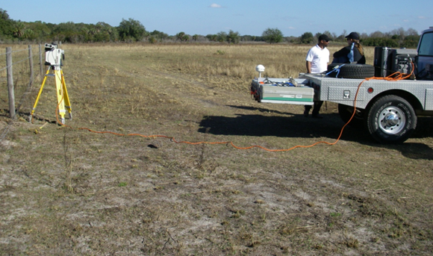 | 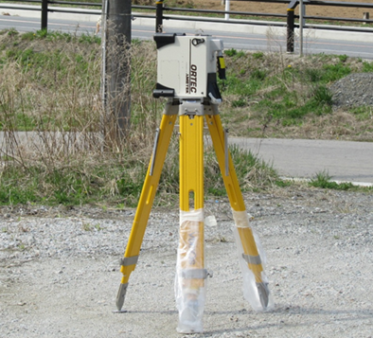
Disconnect HPGe from power source (if battery level permits). If the battery level is low, provide power to the HPGe from an external power source and extension cord  or external battery. | Set up tripod in a stable manner at the desired location. Set the detector facing down on the tripod, positioning it 1m above the ground surface.
 | 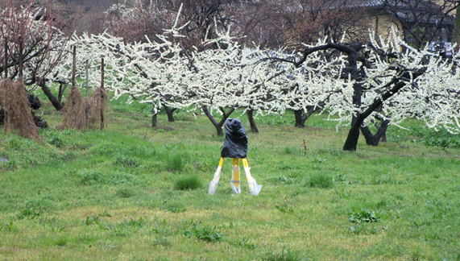
Switch on the system. Check its basic functionality and verify that the dead time does not exceed any limits as noted in the field team instructions. | If it is raining or snowing, cover the HPGe with a waterproof covering.
Collecting an In Situ Measurement
- Push the Identify button, from the Main Menu, to collect the data.
- Spectrum will accumulate until user pauses or the Preset Count time has been reached. If user exits, before saving, then the spectra is lost.
  - While the system is counting, take a picture of the setup from 20-30 feet away showing the surrounding landscape.
- Click on Save. It will save the spectrum file on the SD Card by Date and Time.
- Take notes of the time and any pertinent information (instrument live time, dead time, real time and about the terrain at the measurement location).
  - This information will be entered later into the tablet.
- Submit in situ measurements and photo via the tablet (Reference page 12 of this document).

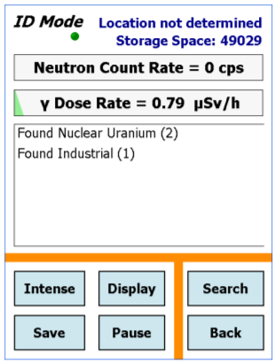

Save button shown
Identify button shown

DFM PROGRAM Submitting a Sample (Spectra)

Any FRMAC tablet can be used with any DETECTIVE.  The following will be collected and transmitted through the DFM Tablet and submitted as a Sample:  - Known source (Cs-137)  - Background (Collected in a representative area before departure to the field)  - Measurements (spectra collected during field team deployments) | 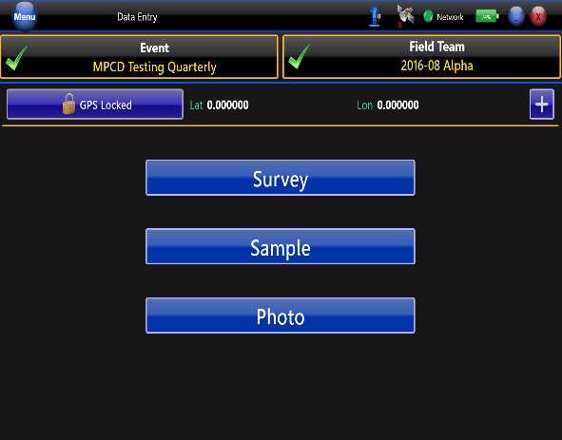 | 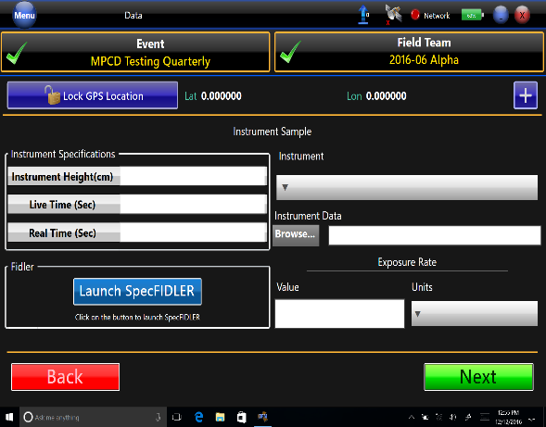
 | Open the DFM (Digital Field Monitoring Program) on the tablet.  Press “Sample.”  Choose “Instrument.”  Insert the SD card from the DETECTIVE into the USB Card reader into the Tablet. | In the “Instrument Specifications” section:  - Record the Instrument Height (cm) – if using the tripod, then the height is 100 cm.  - Record the Live Time (Sec) – Count Time from Detective.  - Record the Real Time (Sec) – If Unknown use the Count Time.

DFM PROGRAM Submitting a Sample (Spectra) continued
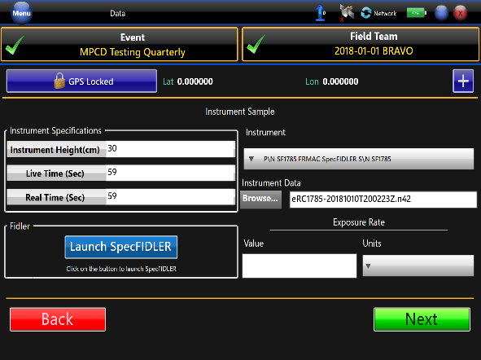 | 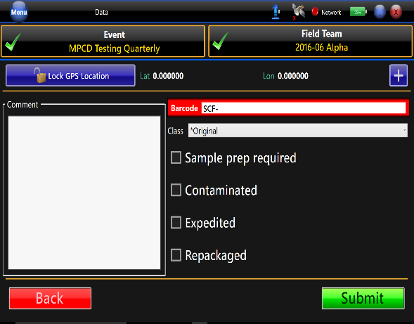 | 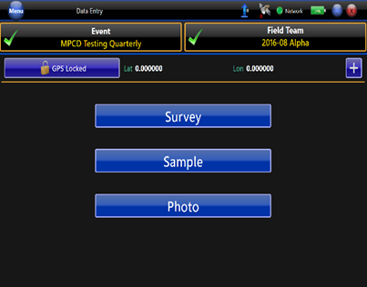
Choose the correct Detective in the “Instrument” drop down list. For a quick search, type the name or description of the detector.  Click “Browse” to find the applicable spectra file on the SD card. After selecting the file, click “Open” and ensure that the file name is in the “Browse” text box in DFM.  Record the exposure rate value and units.  Choose “Next.” | In the “Barcode” section, assign a barcode from a Sample Control Form.  In the “Comments” section, include if the spectra is a background, known nuclide, or a sample and any other pertinent information.  Press “Submit” to send the spectrum and other information to the database.  Secure the SCF form, so the barcode number will not be reused. | Pictures are required. The tablet has a camera. Take pictures of the tripod from a distance so the data analyst is aware of the terrain or if someone has to return they know where the measurement was taken.  Click the Photo button to put the tablet in camera mode.  Tap on the small camera icon (center, right side of the tablet) to take pictures.  To exit, use the close button located at the top right. Be sure to send pictures when sending the data for each measurement.

