Assemble the SpecFIDLER
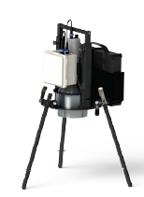 | 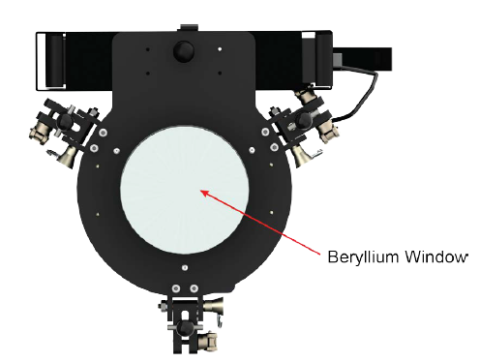 | 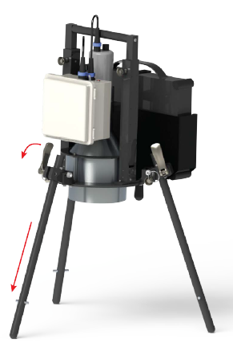
Suggested Equipment  SpecFIDLER  Fully Charged Li-Ion Battery  Tablet Computer  Am-241 Radioactive Source | Beryllium window is very fragile and easily damaged. Remove the protective cap to inspect window. If Undamaged it is safe to use. If the window is damage DO NOT USE! Tape the Cap to the detector and tag “Out of Service”. Notify Field Team Supervisor. | Detector height is 30 cm with legs extended down and out.  To extend legs Loosen clamps, Tighten Clamps to secure height.  Pull the Pin to Lift handle to desired carry height. Reinsert the pins.
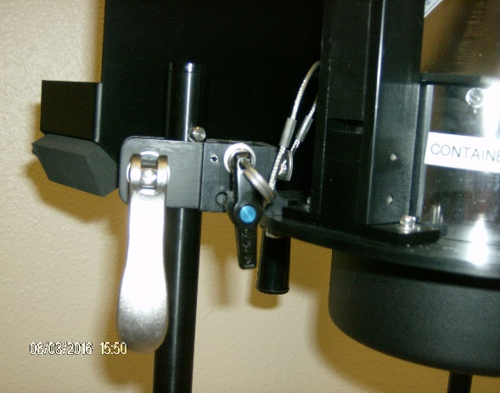 | 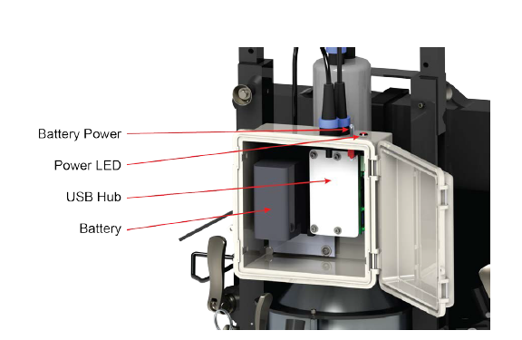 | 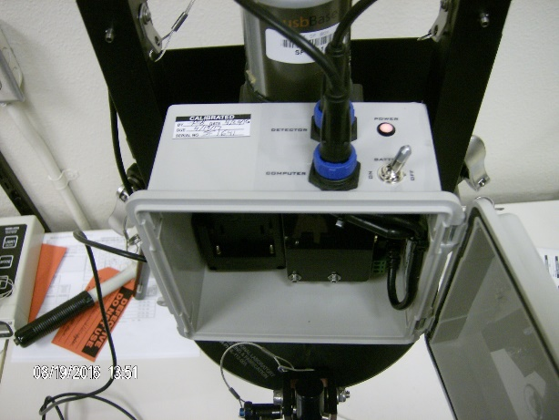
Pull the Pin to swing the Legs Out. Reinsert the Pin secure the leg. Pin Close to detector is for storage. Pin away from detector is for use. | Attach USB Cable to the “Computer” USB on the Battery housing. Install the Li-Ion battery inside the Battery housing. Ensure both battery contacts make a connection. Turn the Power Switch ON before you connect the Tablet. | NOTE: Once the Tablet is connected the Battery Light is ON whether the Switch is ON or OFF. If the battery is not installed the HV will be supplied from the Tablet and shorten Tablet Battery life.
Energy Calibration
Energy Calibration (Speedometer Tab)  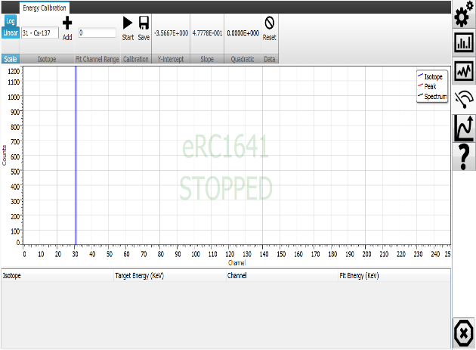 | Energy Calibration 60keV  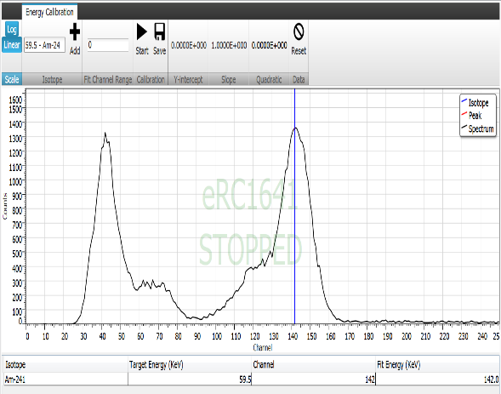 | Energy Calibration 17keV  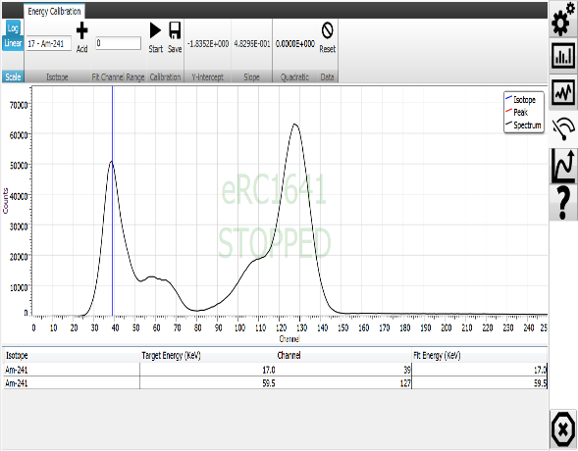
An Energy Calibration should be collected at the beginning of each shift.  Energy Calibration is the process of assigning the peaks of certain isotopes to specific channels. Once it is completed, the spectrum scale will be based on energy, instead of channel. | Start the SpecFIDLER Program  Choose the “Energy Calibration” Tab  Place Am-241 Source Under the Detector Press “Start” to start a count  Choose 59.5 – Am-241 from the “Isotope” drop down  Place the cursor in the center of the 60 KeV peak (Right), after at least 1000 Counts have collected  Press “Add” | Choose 17 – Am-241 from the “Isotope drop down  Place the cursor in the center of the 17 KeV peak (Left) after at least 1000 Counts have collected  Press “Add”.  Press “Stop” to stop current count  Press “Save” to save the new Energy Calibration  Close the SpecFIDLER program

DFM PROGRAM (DIGITAL FIELD MONITORING) Submitting a Sample (Spectra)
Any Tablet can be used with any SpecFIDLER. Ensure the current Setting file has been loaded on the MPCD Tablet before use. Verify the Calibration Sticker Calibration Date matches the SpecFIDLER.exe Settings Tab Efficiency Calibration Date.  For each days mission Keep the Same Tablet and SpecFRIDLER for all measurments. | Submit Sample (Spectra) in DFM  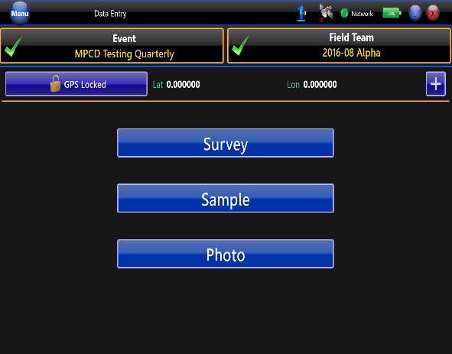 | Submit a Spectra as Sample  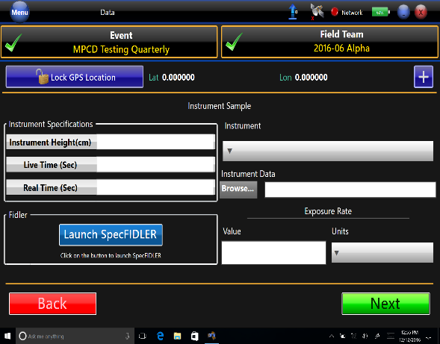
Start of Shift  - Complete an Energy Calibration  The following will be collected and transmitted through the DFM Tablet and submitted as a Sample:  - Known Measurment (Am-241)  - Background (Collected in Parking Lot before departure into the Field)  - Unknown Spectra Collected throught out the day) | Open the DFM (Digital Field Monitoring Program)  Press “Sample” to submit a Spectra  To submit a “Survey” (Measurment result) see page 5 | Choose “Sample” Than “Instrument”  Ensure SpecFIDLER is attached to the Tablet  “Launch SpecFIDLER”  Wait for the SpecFIDLER program to start in the Spectra Tab

DFM PROGRAM (DIGITAL FIELD MONITORING) Submitting a Sample (Spectra)
Collect a Known Source  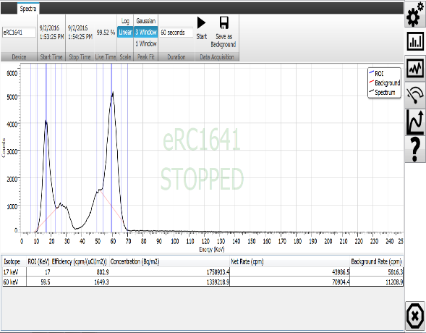 | Or Collect a Background / Unknown  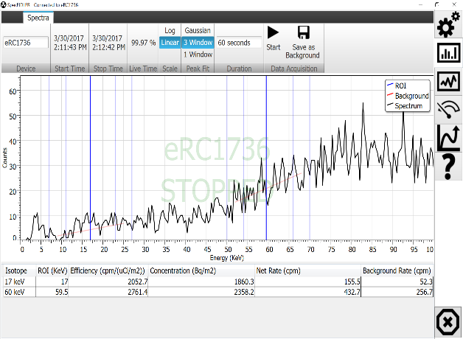 | Return to DFM  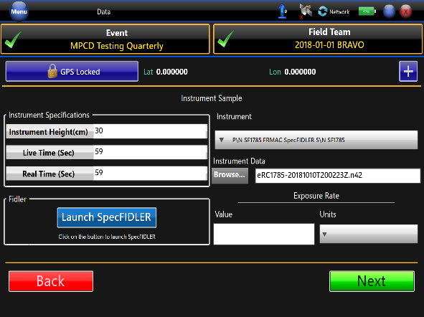
SET Peak Fit to “1 Window”  SET Duration to “60 Seconds”*  PLACE the Am-241 source centered below the detector Face  PRESS “Start”  RECORD all pertinent information on a Daily Instrument QC Check form including:  Instrument Serial Number:  - Instrument Type (Model Number): (SpecFIDLER)  - Depart Date / Time  - QC Check Source Type: (Am-241)  - Check Source ID #:  - Check Source Activity:  - Acceptable Operating Range: (found on the Calibration Sticker)  - Depart Actual Reading; 17 keV and 60 keV Concentration (Bq/m2)  *60 Seconds is a Default. Field Team Supervisor will inform you if a longer count is needed | SET Peak Fit to “1 Window”  SET Duration to “60 Seconds”  PRESS “Start”  *For Background, At the completion of the Count press “Save as Background”  NOTE the following on a piece of paper:  17keV Conectration (Bq/m2)**  60keV Conectration (Bq/m2)**  **In RAMS the 17keV & 60 keV Concentration is stored as two separate Survey probes and recorded as a “Survey.” See “To Submit a Survey” on page 5. | At the End of the Count Time, Close the SpecFIDLER program. After the Shutdown, DFM will be populated with the  Instrument Specifications including  Instrument Serial Number# and the Saved Spectra file name.  Review the information is complete.  Press “Next”.
GOTO the Return to DFM slide
DFM PROGRAM (DIGITAL FIELD MONITORING) Submitting Survey (Measurement)
Assign Barcode to the sample  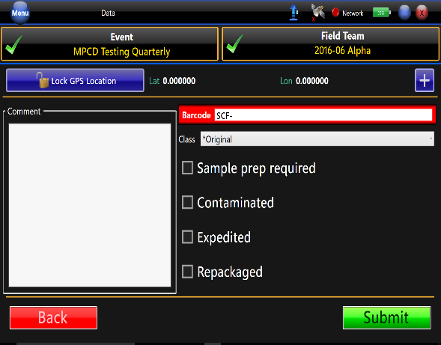 | To Submit a Measurement  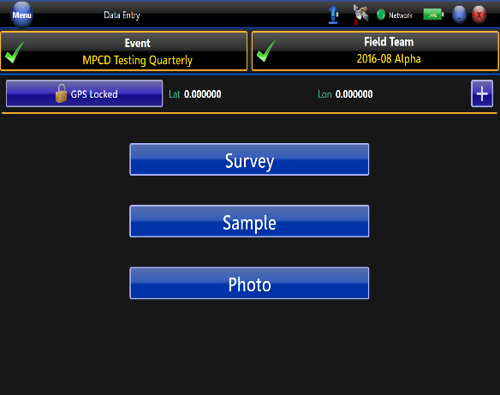 | Choose the Meter & Probe  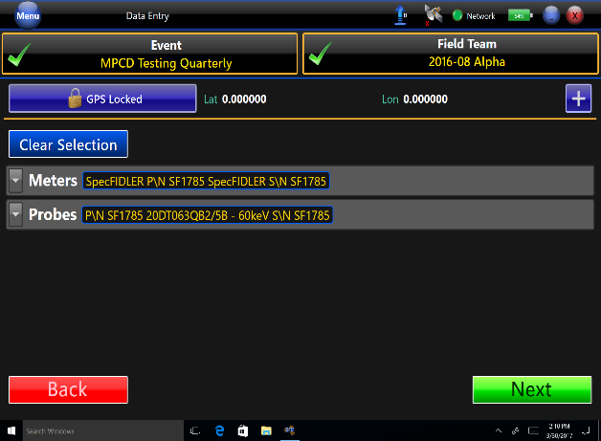
Assign a Barcode from Sample Control Form.  Record any “Comments”. Including if this is a Background, Known or any other pertinent information.  Press “Submit”.  Secure the SCF form, so the Number will not be reused. | Choose “Survey”  To record the SpecFIDLER Measurement values | Choose the Meter of the SpecFIDLER used.  Choose the Probe for 17keV or 60 keV  * In RAMS the 17keV & 60 keV Concentration is stored as two separate Survey probes and recorded as a “Survey”  Choose “Next”
Record Data for the Measurement
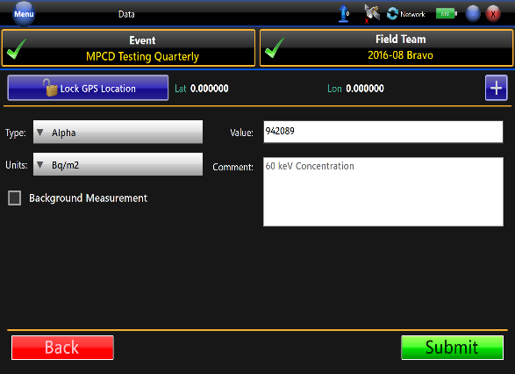
Verify Type is “Alpha”  Choose “Bq/m2” for the Units  Record the 17keV & 60 keV Concentration value for each probe. Press “Submit”. | Submit a picture of the SpecFIDLER and surrounding Area with the Sample Collection Information.
SpecFIDLER Program Tabs
Spectra Acquisition Tab 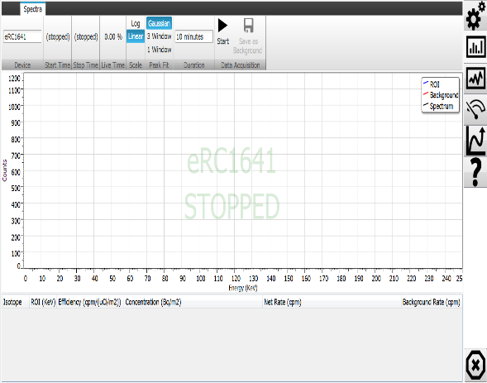 | TAB Definitions 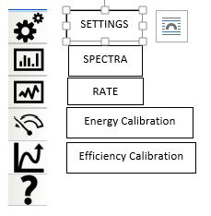 | Settings Tab 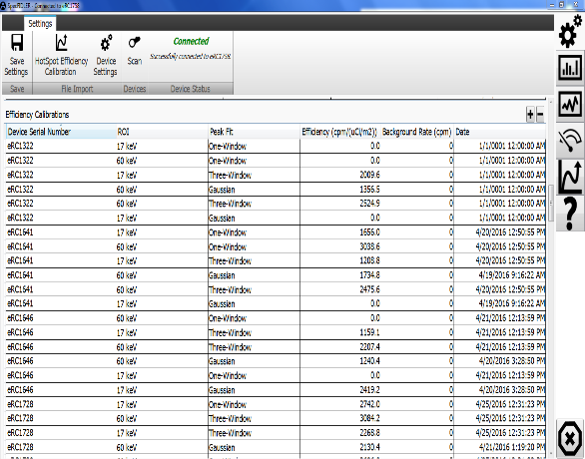
Attach USB cable to Tablet.  Start the SpecFIDLER Program located on the Desk Top. The Screen Defaults to the Spectra Screen. The SF Serial Number should be seen in the background. | Select the Required Tab  “SPECTRA” Tab is the Tab used to collect measurements.  “SETTINGS” Tab Shows Instrument Settings.  “Energy Calibration” Tab Used to set up Instrument and check Gain Shifts | VERIFY the Calibration date on the Calibration Sticker is the same on the Efficiency Calibration date in the Settings Tab. If the Dates do not match the current Efficiency Calibration and Acceptable Operating Range for the Concentration (Bq/m2) will not be correct.
Energy Calibration Tab  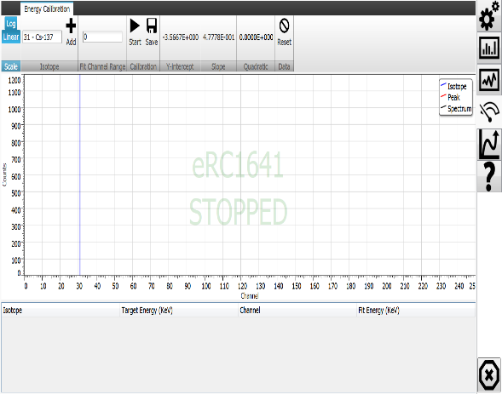 | Rate Tab  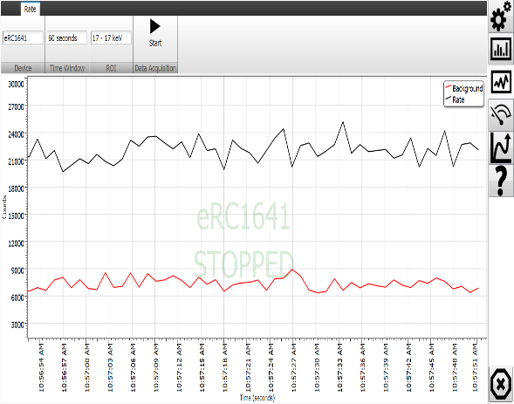 | Spectra Acquisition Tab
Energy Calibration is performed at beginning of shift or after major Temperature change | Rate Mode is used with the legs raised to locate maximum readings when scanning a large area. | Spectra Acquisition is used to collect measurements.
Safe Handling of the Beryllium Window for All Users
The FIDLER (Field Instrument for Detecting Low Level Radiation) detector is a thin window Sodium Iodine Crystal with a Beryllium window.

Beryllium (Be) is a chemical Element. Inhalation of Beryllium dust can lead to Chronic Beryllium Disease. Solid Be windows are OK to work with.

As you are packing and unpacking the detectors and before use and during use examine the Be window. If the window is damaged, secure the protective cover to the detector using tape, Tag the system Out Of Service and notify Field Team Supervisor.

Training for MSTS personnel operating a FIDLER
Beryllium Awareness Briefing (WBT) (1E00W403) will be made a prerequisite to the CMRT Field Monitoring Team, Advanced Training Course for the Field Monitoring Specialist position.
Collateral credit is given by taking course one of the following courses
- Chronic Beryllium Disease Prevention Program (1E000404)
- Underground Worker Safety Training - 8 Hr. MSHA (1E000668)
- Toxic Metals Awareness – WBT (1E00W705)
Training for MSTS personnel responsible for the care and maintenance of FIDLER detectors
Follow the directions in “CD-P-450.014 Chronic Beryllium Disease Prevention”
Complete Chronic Beryllium Disease Prevention Program (Instructor Led) -1E000404

FIDLER DETECTOR DESCRIPTION
A nuclear weapons accident involving a fire or explosion could disperse plutonium isotopes over several square kilometers of varied terrain. A reliable method for determining environmental contamination levels must be available to evaluate the health and safety concerns.
A standard technique for measuring plutonium contamination levels involves the detection of alpha particles. This technique presents a problem for environmental measurements due to the fact that alpha particles are easily absorbed by soil, vegetation, water, etc. The SpecFidler is designed to overcome the problems associated with alpha particle detection by detecting the low energy photons emitted by plutonium and americium.
The SpecFidler uses the FIDLER detector to detect low-energy (11 to 21 keV) x-rays from plutonium and low-energy (26 to 60 keV) gamma rays from americium. The FIDLER’s scintillator consists of a 12.7 cm diameter, 0.16 cm thick NaI (Tl) crystal. The detector entrance window is made of low-Z beryllium, 0.0127 cm thick.
The FIDLER detector is very sensitive to photons with energies from 5 to 100 keV, with very little Compton background from higher-energy photons. The FIDLER converts each counted photon into an electrical pulse whose height is proportional to the energy of the photon. The SpecFidler sorts the pulses by energy and develops an energy spectrum. From this spectrum, the SpecFidler can distinguish which photons are from americium and which photons are from plutonium.
Two regions of the spectrum, called regions of interest (ROI), are used in the calculation of plutonium and americium concentrations. The lower region (ROI 17) encompasses the L x-rays (11 to 21 keV) emitted by both plutonium and americium, commonly called the 17 keV peak. The upper region (ROI 59.5) encompasses the 60 keV peak of gamma rays emitted by americium. Each region is defined by lower and upper limits that are set during the calibration procedure. The limits are set at the approximate channel where the counts are less than or equal to one-half the counts in the peak channel.
The SpecFidler is controlled by tablet or laptop that has the installed SpecFidler application.

