Job Aid – Changing Sample Status

Changing Sample Status Using Barcode Utility
- Hover over the tab and click on .
- Verify that the radio button is selected.
- Scan or manually enter samples #.
- Click on .
- Repeat steps 3 and 4 until all samples have been entered.
- Check the {Update Status} box.
- “Status” box appears.
- Pull down the “Status” window and select the appropriate status.
- Click on .
- A window should pop open confirming that the sample status has been changed. 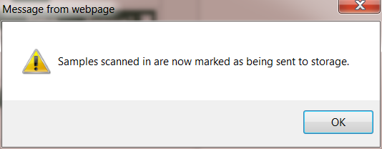
- Click on 

