Print Sample Control Forms and Barcode Numbers in CBRNResponder
In the past, the Consequence Management Response Team (CMRT) and Federal Radiological Monitoring and Assessment Center (FRMAC) would provide states with sample control forms and sample barcode numbers. This can now be done by the local response organization.
- The current FRMAC “Sample Control Form” can be found online here: https://nnss.gov/mission/federal-radiological-monitoring-and-assessment-center-frmac/relevant-documents-and-manuals/. Simply download the form and print.
- The sample barcodes can be printed from CBRNResponder (https://www.radresponder.net). Since this is relatively new, please see the procedure below to print barcodes.
How to Print Barcodes in CBRNResponder
- Open CBRNResponder and choose any event. This does not have to be the same event in which samples would be collected.
- Click “Reports” from the side menu (see figure 1).
- Click “Generate Barcodes” to generate sample barcode labels for an Avery 5160, 30 labels per sheet, template.
- Fill out the required information in the “Print Sample Labels” form (see figure 2).
  - Organization*: Choose your organization from the drop-down list.
  - Print Type*: Select “Print New” for a new set of unique sequential numbers. Select “Reprint existing” to reprint a new barcode for an issued number.
  - Quantity*: Choose how many new numbers you want to print. CMRT/FRMAC default is 30 numbers.
  - Copy Quantity*: Choose how many duplicate labels you want. CMRT/FRMAC default is 3.
NOTE: A sheet will have 10 sequential numbers (one per column) with 3 copies per row (see figure 3).
  - Label Prefix: The prefix “SCN” (Sample Control Number) is the CBRNResponder default. The prefix “SCF” (Sample Control Form) is the CMRT/FRMAC default.
  - Barcode start number*: If “reprinting existing,” then enter the sample number (range) to be printed.
  - Barcode range to be printed: Review the range of numbers to be printed.
  - Barcode Type*: Choose PDF417 or CODE39. CMRT/FRMAC default is PDF417. Most cameras and scanners will detect either barcode type.
- Review the “Example Barcode” and make any changes as needed.
NOTE: SCN-XXX-YYYYYY: “XXX” is the 3-digit code in CBRNResponder for your organization and “YYYYYY” is the unique sequential number.
- Click “Print Labels” and the barcodes will be generated as a pdf. Save the pdf. Print the labels on Avery 5160 or similar template.
- If you are unable to print your own forms and barcodes, please contact a FRMAC representative for assistance.

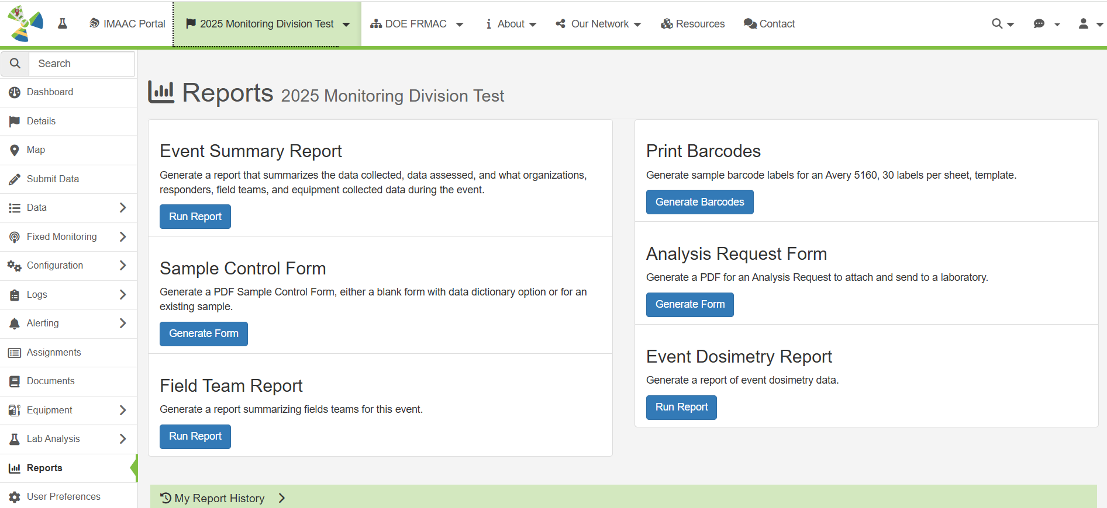
Figure 1: Screen in CBRNResponder when “Reports” is selected.

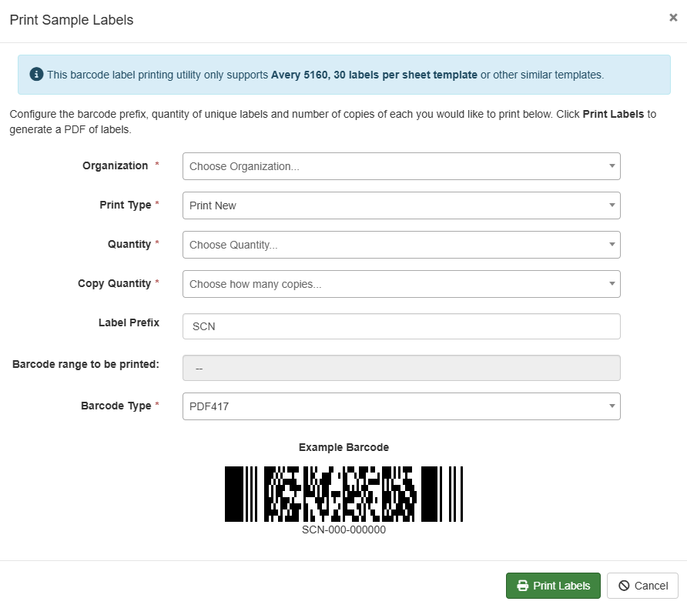
Figure 2: The “Print Sample Labels” screen in CBRNResponder.
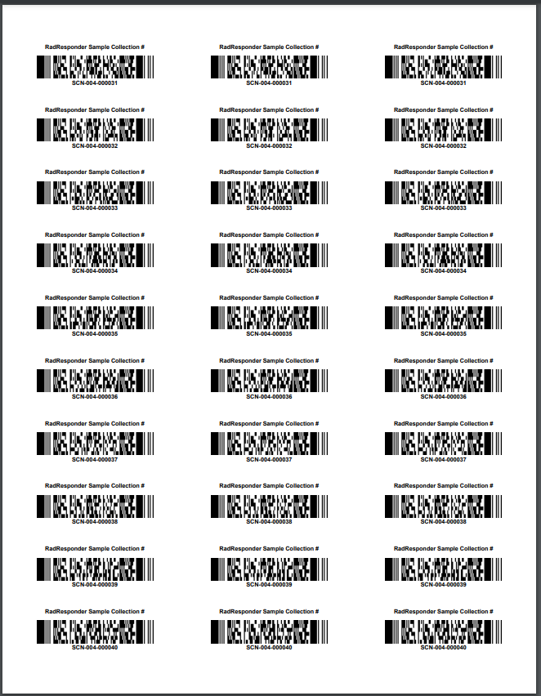
Figure 3: Example of a barcode printout from CBRNResponder.

